ROLE OF HLD AND LLD IN SYSTEM DESIGN AND DATA ENGINEERING
HLD and LLD in System Design and Data Engineering — Complete Master Guide
If you want to prepare for Data Engineering interviews at companies such as Amazon, Google, Microsoft, and other large technology companies, you need to understand two fundamental parts of system design:
- HLD — High-Level Design: How the entire system is architected.
- LLD — Low-Level Design: How individual components of that system are structured and implemented.
Both are important, but they solve different problems. HLD helps you reason about architecture, data flow, scalability, storage, reliability, and cost. LLD helps you reason about Python classes, SQL schemas, algorithms, interfaces, validations, error handling, and testing.
We will build this understanding from the basics, with examples specifically focused on Data Engineering.
1. First, understand what System Design means
System design is the process of planning how different components work together to solve a problem reliably and efficiently.
Imagine that you are asked to design a data platform that collects product prices from Amazon, Blinkit, Zepto, BigBasket, and Swiggy Instamart.
The platform must:
- Collect product information from different sources.
- Store the original data.
- Clean inconsistent product names and units.
- Match the same product across platforms.
- Compare prices and availability.
- Store historical snapshots.
- Display the results in a dashboard.
- Recover from failures without producing duplicate records.
- Support an increasing number of products and locations.
A single Python script might work for a small experiment, but a production system needs a much more deliberate design.
That is where HLD and LLD come in.
HLD: The complete architecture
Data sources → Ingestion → Storage → Processing → Warehouse → Dashboard
Which components are needed, how they communicate, and why they are chosen.
Component responsibilities and interfaces
LLD: The internal implementation
Python functions → Validation → Deduplication → SQL operations → Tests
How each component behaves, processes data, and handles errors.
A useful analogy is constructing a building.
- HLD determines the overall structure, floors, entrances, electrical layout, and major systems.
- LLD determines the specific wiring, connections, dimensions, materials, and implementation details.
In software, the HLD defines the architecture; the LLD defines the internal design of its components.
2. What is HLD — High-Level Design?
2.1 Definition
High-Level Design describes the overall architecture of a software or data system.
It identifies the major components, their responsibilities, their interactions, and the decisions needed to meet the system's requirements.
An HLD typically covers:
- Functional and non-functional requirements.
- Major services and components.
- Data flow between components.
- Databases, data lakes, and warehouses.
- APIs and communication protocols.
- Batch versus streaming architecture.
- Scalability and capacity.
- Availability and fault tolerance.
- Security and governance.
- Monitoring and operational requirements.
- Cost and architectural trade-offs.
HLD is not simply a drawing of boxes and arrows. It must explain why the architecture satisfies the requirements.
2.2 Example: designing a product-price comparison platform
Suppose the system collects 10 million product observations per day.
A possible HLD is:
1. Data sources
Retail catalogues · APIs · Files · Inventory feeds
2. Ingestion layer
Python collectors · Connectors · Optional Kafka producers
3. Raw data storage
Original records · Source metadata · Ingestion timestamps
4. Transformation layer
Cleaning · Validation · Deduplication · Product matching
5. Curated storage
Standardized product records · Price history · Availability
6. Analytical serving
Warehouse · BI dashboards · Reports · Analytics APIs
Supporting components: workflow orchestration, data quality, monitoring, access control, cataloguing, and lineage.
This diagram answers the main architectural question: how will data travel from its source to the user?
It does not yet explain the exact Python functions or SQL statements. Those belong to LLD.
2.3 The role of HLD: eight major responsibilities
A. Requirement analysis
Before choosing technologies, understand what the system must achieve.
Functional requirements describe what the system does.
Examples:
- Ingest product information.
- Calculate price differences.
- Store historical records.
- Match products across retailers.
- Provide dashboard filters.
- Generate daily reports.
Non-functional requirements describe how well the system must work.
Examples:
- Process 10 million records per day.
- Make data available within 15 minutes of collection.
- Recover from a failed pipeline.
- Support hundreds of concurrent dashboard users.
- Protect sensitive information.
- Keep operating costs within budget.
A good HLD begins by clarifying requirements instead of immediately selecting Kafka, Spark, or a cloud provider.
B. Choosing the system architecture
HLD decides which major components are needed.
For example:
Requirement | Possible architectural decision
Collect data from multiple sources | Ingestion services or connectors
Retain original records | Durable raw storage
Process large datasets | Distributed processing, if justified
Coordinate daily workflows | Airflow or another orchestrator
Support analytical queries | Warehouse or analytical tables
Serve frequently requested results | Cache, if needed
Monitor pipeline failures | Metrics, logs, and alerting
These are possible solutions, not mandatory technology choices.
For a modest nightly pipeline, Python, SQL, and a database might be sufficient. For high-volume distributed processing, a data lake, Spark, and an orchestrator might make more sense.
HLD's job is to select an appropriate architecture for the actual requirements.
C. Defining data flow and component communication
HLD determines how information moves between services.
For example:
- A source produces product data.
- An ingestion service collects the records.
- The records are written to raw storage.
- A transformation job reads the records.
- Valid data is cleaned and standardized.
- Invalid records are quarantined.
- Curated data is written to analytical storage.
- Dashboards query the curated data.
You also decide how components communicate:
- REST or other APIs.
- Files in object storage.
- Database connections.
- Message brokers.
- Scheduled jobs.
- Streaming events.
One important decision is whether processing should be synchronous or asynchronous.
For example, a dashboard request should generally not wait for an entire historical dataset to be processed. The pipeline can process data separately and publish the results for the dashboard to read.
D. Designing scalability
Scalability means handling growth in workload without unacceptable performance degradation or cost.
There are two common approaches.
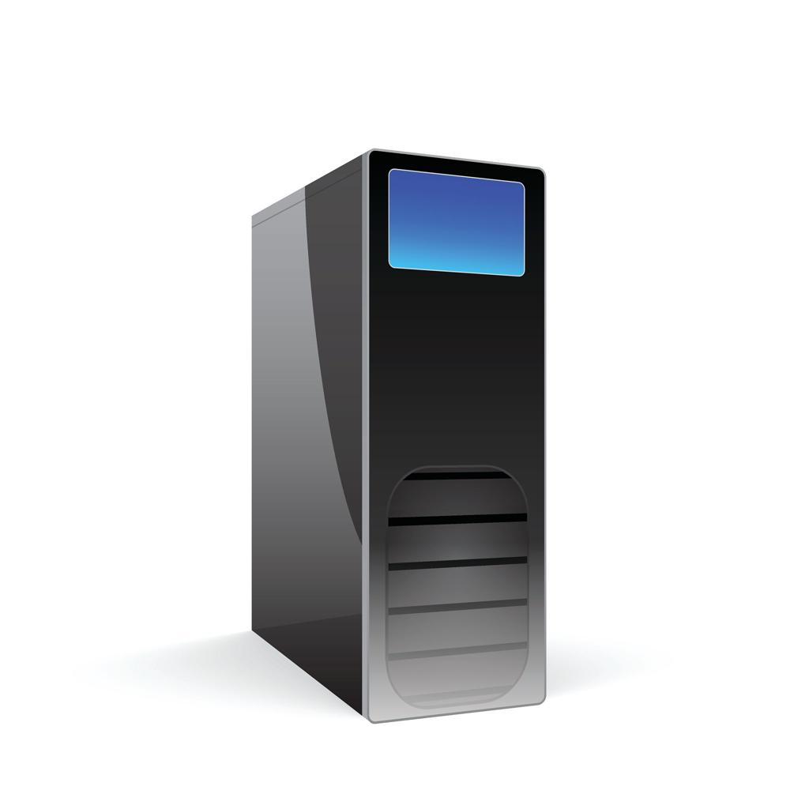
Vertical scaling
Increase the CPU, RAM, or disk capacity of an existing machine.
Example: upgrade a server from 8 GB to 64 GB RAM.
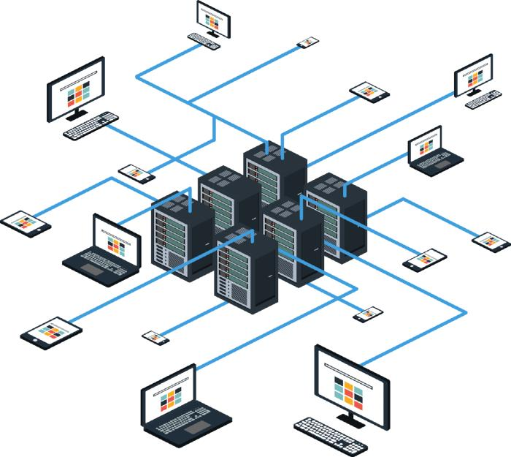
Horizontal scaling
Add machines or workers and distribute the workload.
Example: process partitions across multiple Spark executors.
In Data Engineering, HLD scaling decisions include:
- Partitioning large datasets.
- Increasing processing parallelism.
- Managing Kafka partitions and consumer capacity.
- Separating storage from compute where supported.
- Using incremental transformations instead of repeatedly processing all history.
- Avoiding bottlenecks in ingestion and downstream storage.
- Choosing suitable file sizes and formats.
- Planning for peak traffic rather than just average traffic.
Suppose a Python pipeline processes 100,000 rows per day today but must process 100 million rows per day next year.
HLD should consider how the architecture will evolve. The answer may be better batching, optimized SQL, partitioned files, or distributed compute; the correct solution depends on the actual bottleneck.
E. Designing availability and fault tolerance
A production data system must account for failures.
Potential failures include:
- A source API becoming unavailable.
- A collector crashing.
- A Spark task failing.
- A database connection timing out.
- A scheduled job running twice.
- A warehouse load completing partially.
- A schema change breaking a downstream transformation.
HLD establishes the recovery strategy.
Mechanism | Purpose
Replication | Preserve copies of data or services
Retries | Recover from temporary failures
Checkpointing | Resume processing from saved progress
Dead-letter queues | Isolate unprocessable events
Idempotency | Make repeated operations safe
Backups | Recover from data loss or corruption
Monitoring | Detect errors and degraded performance
Disaster recovery | Restore operations after a major incident
These mechanisms solve different problems. For example, retries alone do not prevent duplicate records, and replication does not automatically prevent incorrect business logic.
F. Designing storage and data models
HLD decides where different types of data should live.
- Operational databases: support transactional application workloads.
- Data lakes: retain large volumes of raw and processed data.
- Data warehouses: support analytical SQL and BI queries.
- Caches: serve frequently accessed results.
- Metadata catalogs: describe datasets, schemas, ownership, and lineage.
HLD also establishes the broad analytical model.
For a retail platform, you might define:
- dim_product
- dim_location
- dim_date
- fact_product_price
- fact_inventory_snapshot
At the HLD level, you establish what these tables represent and how they relate. At the LLD level, you define the exact columns, types, constraints, keys, and SQL.
G. Security and governance
HLD must account for data protection throughout the system.
Examples include:
- Authentication and authorization.
- Encryption at rest and in transit.
- Secrets management.
- Network access restrictions.
- Role-based access control.
- Data retention policies.
- Personally identifiable information controls, where relevant.
- Data lineage and ownership.
- Audit logging.
LLD then specifies the detailed policies, roles, configuration, and enforcement points.
H. Performance, cost, and trade-offs
There is rarely one perfect architecture.
Consider a daily pipeline processing 50 GB of data.
You could use:
- Python on one machine.
- Scheduled SQL transformations.
- A distributed Spark cluster.
- A managed cloud ETL service.
Each has advantages and disadvantages.
HLD compares them using:
- Volume and growth.
- Freshness requirements.
- Query latency.
- Operational complexity.
- Infrastructure cost.
- Team skills.
- Reliability requirements.
The most advanced technology is not automatically the best technology. A simple architecture that meets all requirements can be preferable to an unnecessarily complicated one.
3. What is LLD — Low-Level Design?
3.1 Definition
Low-Level Design describes the internal implementation of a component or subsystem.
It specifies how that component is divided into modules, how its functions interact, how its data is structured, and how it behaves in normal and failure scenarios.
LLD typically covers:
- Classes and objects.
- Functions and methods.
- Interfaces and contracts.
- Input and output schemas.
- Database tables and constraints.
- SQL queries.
- Algorithms and complexity.
- Validation rules.
- Error handling and retry behaviour.
- Configuration.
- Logging and metrics.
- Unit and integration tests.
Suppose HLD says that your platform needs a product ingestion service.
LLD explains how to implement that service.
3.2 Designing the ingestion service
A reasonable module structure might be:
ingestion/
├── interfaces.py
├── blinkit_source.py
├── bigbasket_source.py
├── normalizer.py
├── validator.py
├── storage.py
├── retry.py
├── config.py
└── tests/
├── test_normalizer.py
├── test_validator.py
└── test_storage.py
Each module has a specific responsibility.
Module | Responsibility
interfaces.py | Define contracts for source collectors
blinkit_source.py | Collect data from Blinkit
bigbasket_source.py | Collect data from BigBasket
normalizer.py | Standardize names, fields, and units
validator.py | Detect missing or invalid records
storage.py | Persist raw or processed data
retry.py | Implement retry policies
config.py | Hold configurable settings
tests/ | Verify correctness and edge cases
This modular breakdown is an LLD decision.
It makes it easier to add another retailer, replace a storage implementation, or change validation rules without rewriting the whole pipeline.
3.3 The major responsibilities of LLD
A. Defining classes and functions
A class should have a clear responsibility.
For example:
- ProductCollector fetches product records.
- ProductNormalizer standardizes the data.
- ProductValidator checks correctness.
- ProductMatcher identifies equivalent products.
- PriceRepository saves and retrieves records.
- PipelineRunner coordinates the process.
These are illustrative class names, not a requirement to use object-oriented programming everywhere. Some transformations are simpler and clearer as standalone functions.
The important principle is separation of concerns.
A giant class that collects data, cleans it, matches products, writes SQL, generates reports, and sends alerts is difficult to test and maintain.
B. Defining interfaces and contracts
An interface specifies what a component promises to do.
For example:
class ProductNormalizer: def normalize(self, record: dict) -> dict: ...
The LLD must specify:
- Required input fields.
- Accepted data types.
- Output fields.
- Output data types.
- Behaviour for missing values.
- Behaviour for invalid values.
- Whether the original record is modified.
- What errors are raised.
Consider this input:
record = { "product_name": "Tomato", "price": "₹40", "quantity": "500 g"}
A normalization contract might produce:
{ "product_name": "Tomato", "price": 40.0, "quantity_value": 500.0, "quantity_unit": "g"}
A real implementation must also define how it handles commas, currency, discounts, decimal precision, unsupported units, and ambiguous pack sizes.
C. Defining schemas and constraints
LLD specifies the precise structure of stored data.
A simplified table might be:
Column | Data type | Purpose
snapshot_id | BIGINT | Record identifier
product_id | VARCHAR | Canonical product ID
source | VARCHAR | Retail platform
location_id | VARCHAR | Store or delivery location
price | DECIMAL(10,2) | Observed price
quantity_value | DECIMAL(10,3) | Pack quantity
quantity_unit | VARCHAR | g, kg, ml, l, etc.
available | BOOLEAN | Availability at observation time
observed_at | TIMESTAMP | Observation time
A simplified SQL definition:
CREATE TABLE fact_product_price (
snapshot_id BIGINT PRIMARY KEY,
product_id VARCHAR(100) NOT NULL,
source VARCHAR(50) NOT NULL,
location_id VARCHAR(100) NOT NULL,
price DECIMAL(10, 2),
quantity_value DECIMAL(10, 3),
quantity_unit VARCHAR(20),
available BOOLEAN NOT NULL,
observed_at TIMESTAMP NOT NULL
);
The actual DDL may differ for PostgreSQL, BigQuery, Snowflake, or another database.
The LLD must also specify:
- Which columns may be null.
- Which fields form the business key.
- How duplicates are detected.
- How historical changes are represented.
- What happens when a product becomes unavailable.
- How late-arriving data is handled.
- Whether records are appended, overwritten, or merged.
D. Defining algorithms and complexity
LLD describes the algorithms used inside components.
Suppose you need to remove duplicate records.
A nested-loop comparison of every record against every other record may require \(O(n^2)\) comparisons.
A dictionary-based method can usually perform deduplication in expected \(O(n)\) time for \(n\) records, assuming efficient hashing.
def remove_duplicates(records): unique_records = {} for record in records: key = ( record["source"], record["location_id"], record["product_id"], record["observed_at"] ) unique_records[key] = record return list(unique_records.values())
This example keeps the last record encountered for each key.
A production design must decide whether that is correct. If two records with the same key contain conflicting prices, you might instead select the record with the latest ingestion timestamp or quarantine the conflict.
This is where Python and DSA knowledge becomes useful in LLD interviews: you need to reason about correctness, edge cases, memory usage, and time complexity.
E. Designing error handling
LLD must define how failures are handled within a component.
For example, a source request may fail because of a timeout or invalid request.
A robust retry policy should:
- Identify which failures are temporary.
- Retry only appropriate failures.
- Limit the number of attempts.
- Apply backoff between retries.
- Record errors and relevant metadata.
- Raise an error or quarantine data when recovery is exhausted.
- Avoid repeating non-idempotent operations without safeguards.
A simplified implementation:
import timedef run_with_retry(operation, max_attempts=3): for attempt in range(max_attempts): try: return operation() except TemporaryError: if attempt == max_attempts - 1: raise time.sleep(2 ** attempt)
TemporaryError is a placeholder for an exception you would define or replace with the appropriate exception type.
Production code also needs timeouts, jitter, retryable status codes, cancellation, logging, and an explicit maximum duration.
F. Ensuring idempotency
An operation is idempotent when repeating it with the same logical input produces the same intended final state without unintended duplicate effects.
Suppose an Airflow job inserts 100,000 records and fails after inserting 60,000. When the job reruns, those first 60,000 records may be inserted again unless the design prevents it.
Possible solutions include:
- Unique business keys.
- Deterministic record identifiers.
- Upserts or merge operations.
- Processed-batch tracking.
- Transactional commits.
- Checkpoints.
- Atomic publication of completed datasets.
LLD determines the exact key and write strategy.
For example, source, location, product, and observation time might define a unique snapshot. However, if multiple observations at the same timestamp are legitimate, that key would need to be revised.
G. Designing tests
LLD must explain how correctness will be verified.
Test type | Example
Unit test | Verify price parsing
Unit test | Verify grams-to-kilograms conversion
Unit test | Reject negative prices
Integration test | Write data to a test database
Integration test | Verify warehouse merge behaviour
End-to-end test | Run the full pipeline on sample records
Data-quality test | Check nulls, duplicates, and invalid ranges
Failure test | Simulate a timeout and verify retry behaviour
A job completing successfully does not prove that its output is correct. Testing must verify both operational behaviour and data quality.
4. The most important difference: HLD vs LLD
Consider the requirement: “Build a reliable product-price ingestion pipeline.”
Design question | HLD answer | LLD answer
What components are needed? | Collectors, raw storage, processing, warehouse | Specific classes and modules
How does data move? | Source → ingestion → processing → storage | Method calls, message formats, file interfaces
Where is data stored? | Object storage and analytical database | Table DDL, column types, constraints
How are records cleaned? | A standardization component | Exact Python transformation rules
How are duplicates prevented? | Safe reruns are required | Unique keys, merge logic, transaction handling
How are failures recovered? | Retry and recovery architecture | Exception types, backoff, timeouts
How is the system scaled? | Distributed processing or more workers | Partition functions, efficient joins, memory use
How is quality monitored? | Quality gates and alerting | Metrics, test assertions, error records
How is the system secured? | Identity and access-control architecture | Specific roles, permissions, secret handling
The key distinction is not simply the size of the diagram or the amount of code.
HLD focuses on the system's structure and architectural trade-offs. LLD focuses on the detailed behaviour and implementation of its components.
5. How HLD and LLD work together in a Data Engineering pipeline
Let's follow the lifecycle of a real record.
Suppose the source reports:
{ "name": "Tomato", "price": "40", "quantity": "500 g", "location": "Bangalore"}
The goal is to store a standardized product-price observation for analytics.
Step 1: HLD decisions
At the architectural level, you decide:
- Collect data from all supported sources.
- Preserve the original records.
- Run validation and transformation.
- Store standardized observations.
- Retain historical price data.
- Make the data available to the dashboard.
- Orchestrate the workflow and monitor its status.
Step 2: LLD decisions
At the implementation level, you decide:
- How the source collector returns data.
- How "40" is converted to a numeric price.
- How "500 g" is parsed into a numeric quantity and unit.
- How Bangalore maps to a canonical location ID.
- How missing values are represented.
- Which fields define a duplicate.
- How a failed write is retried safely.
- Which tests verify the transformed record.
Step 3: Data quality
The transformed record might be:
{ "product_name": "Tomato", "price": 40.00, "quantity_value": 500.0, "quantity_unit": "g", "location_id": "BLR_001"}
The pipeline must check whether the values are valid before storing them.
For example, a negative price should be rejected or quarantined. A missing price might be allowed for an unavailable product, depending on the data contract.
Step 4: Storage and consumption
The curated record is saved to the analytical store.
The dashboard can then compare the product's price across sources and locations, or track how the price changes over time.
The HLD makes the complete flow possible. The LLD ensures each step works correctly.
6. HLD and LLD across major Data Engineering technologies
Technology or area | HLD responsibilities | LLD responsibilities
ETL/ELT | Decide where transformations occur | Write transformations, mappings, and validation rules
Airflow | Define workflow structure and dependencies | Define DAGs, task parameters, retries, and timeouts
Kafka | Define event architecture and partition strategy | Define message schemas, consumer logic, and error handling
Spark | Choose distributed processing architecture | Implement DataFrame transformations, joins, and aggregations
Data warehouse | Define analytical architecture and subject areas | Define table schemas, keys, SQL, and incremental loads
Data lake | Define raw and curated data zones | Define file layouts, naming, metadata, and partition rules
CDC pipelines | Define change-data-capture flow | Handle offsets, deletes, ordering, and merge logic
Data quality | Define quality gates and escalation | Implement checks, thresholds, and error formats
Security | Define trust boundaries and access architecture | Configure roles, permissions, and secrets
Monitoring | Define SLAs, metrics, and alert strategy | Instrument logs, counters, and alert thresholds
These areas frequently require decisions at both levels.
For example, HLD may decide that the system supports historical backfills. LLD determines how to pass date ranges into a job, overwrite or merge the affected partitions, recalculate aggregates, and prevent conflicting concurrent runs.
7. How to solve HLD questions in interviews
When an interviewer asks you to design a large data system, use a repeatable process rather than jumping straight into technology choices.
- Clarify the requirements
Ask about data sources, volume, growth, freshness, consumers, retention, security, and budget. Separate functional requirements from non-functional requirements.
- Estimate the scale
Estimate daily records, peak throughput, average record size, storage growth, and processing time. State assumptions clearly.
- Draw the architecture
Include ingestion, raw storage, transformation, curated storage, serving, orchestration, and monitoring as needed.
- Explain the data flow
Follow one record from source to destination and identify validation, transformation, and storage steps.
- Define the data model
Establish the grain, keys, facts, dimensions, history requirements, and access patterns.
- Discuss reliability and scale
Explain partitioning, parallelism, retries, idempotency, checkpoints, backfills, and recovery.
- Address security and operations
Cover access control, secrets, encryption, lineage, monitoring, alerting, and service-level objectives.
- Explain trade-offs
Compare reasonable alternatives and justify your choice against the requirements.
Example interview opening
Question: “Design a platform that collects price data from 10,000 retailers.”
A good answer might begin:
“I would first clarify the collection frequency, data volume, freshness requirements, historical retention, and query patterns. Assuming the platform collects data every 15 minutes and supports historical price comparisons, I would design an ingestion layer that writes original records to durable raw storage. A processing layer would validate, deduplicate, normalize units, and match products. The curated output would be stored in an analytical system for dashboard queries. I would use batch or streaming processing based on the required freshness and workload, and I would include orchestration, data-quality checks, monitoring, and a safe recovery mechanism.”
This answer demonstrates structured reasoning. You can then discuss the specific technologies and their trade-offs.
8. How to solve LLD questions in interviews
LLD interviews typically require more precise reasoning about component responsibilities and implementation.
- Define the component's purpose
Is it a collector, normalizer, validator, matcher, repository, or orchestrator?
- Specify the input and output contracts
Define required fields, types, output format, and error behaviour.
- Identify classes and functions
Assign clear responsibilities and avoid unnecessary abstractions.
- Design the schema
Define columns, types, keys, constraints, and nullability.
- Choose the algorithm
Explain correctness, edge cases, time complexity, and space complexity when relevant.
- Handle failures
Consider malformed records, duplicates, timeouts, partial writes, and retries.
- Implement and test
Write Python or SQL for the important path and explain how you would verify it.
Example LLD question: design a price validator
Requirements:
- product_id must exist.
- source must exist.
- price must be numeric.
- price must not be negative.
- observed_at must be present.
A basic implementation:
import mathdef validate_price_record(record): required_fields = [ "product_id", "source", "price", "observed_at" ] for field in required_fields: if record.get(field) is None: return False try: price = float(record["price"]) except (ValueError, TypeError): return False if not math.isfinite(price) or price < 0: return False return True
Example input:
record = { "product_id": "P101", "source": "Blinkit", "price": "40.00", "observed_at": "2026-10-22T10:00:00"}print(validate_price_record(record))
Output:
True
This is an illustrative implementation, not a complete production validator. A stronger design would parse and validate the timestamp, check currency and precision, return structured validation errors, and distinguish missing data from invalid data.
In an interview, you should explain not only how the function works but also what the pipeline does when a record fails validation.
9. Important advanced concepts that connect HLD and LLD
9.1 Batch versus streaming
- HLD: Decide whether the freshness requirement justifies streaming, micro-batching, or scheduled batch processing.
- LLD: Implement event parsing, offset management, window calculations, late-event handling, and retry behaviour.
9.2 Exactly-once processing
- HLD: Establish the required delivery and processing guarantees.
- LLD: Implement stable event IDs, transactions, deduplication, and destination-side merge behaviour.
Do not assume that a message broker's exactly-once feature automatically guarantees exactly-once business effects across the entire pipeline.
9.3 Schema evolution
- HLD: Decide how producers and consumers manage changes in data structure.
- LLD: Define schema versions, compatibility rules, defaults, type conversions, and behaviour for missing fields.
9.4 Backfills and late-arriving data
- HLD: Ensure the architecture supports historical reprocessing and late data.
- LLD: Implement date-range parameters, partition replacement, merge rules, aggregate recalculation, and concurrency controls.
9.5 Observability
- HLD: Decide which metrics matter and how alerts are escalated.
- LLD: Define specific logs, counters, and thresholds.
Examples include:
- Records read and written.
- Invalid-record count.
- Duplicate-record count.
- Processing duration.
- Data freshness.
- Retry count.
- Failed partition count.
A job can succeed technically while producing no data or incorrect data, so data observability is as important as job monitoring.
10. Common mistakes to avoid
Choosing tools before understanding requirements
Saying “I will use Kafka, Spark, and Airflow” is not a complete design.
Instead, explain what each tool solves and why a simpler alternative might or might not work.
Treating HLD as just a diagram
An architecture diagram does not explain its trade-offs, failure modes, or bottlenecks.
Explain why the components are needed and how the design meets the requirements.
Treating LLD as just code
Code can run but still be unsafe to rerun, difficult to test, or ambiguous about invalid records.
Define contracts, schemas, responsibilities, edge cases, and tests.
Ignoring data correctness
A fast and available pipeline can still produce incorrect analytics.
Define table grain, keys, quality checks, deduplication, and reconciliation.
Overengineering the system
A complex streaming platform may be unnecessary for a small nightly dataset.
Start with the simplest architecture that meets the requirements and describe how it can evolve.
11. Which one is more important for Data Engineering interviews?
Both matter, but HLD generally deserves more dedicated practice for data-platform system-design rounds, while LLD demonstrates implementation depth. The balance varies by company, seniority, and interview format.
Skill | HLD importance | LLD importance
Architecture and data flow | Very high | Medium
Distributed systems | Very high | Medium–high
Batch and streaming design | Very high | High
Data modelling | High | Very high
Python implementation | Low–medium | Very high
SQL and transformations | Medium | Very high
Fault tolerance | High | Very high
Data quality | High | Very high
Scalability and capacity | Very high | High
Testing and maintainability | Medium | Very high
For your preparation, prioritize:
- SQL and data modelling.
- Python and core data structures.
- ETL/ELT architecture.
- Distributed processing and storage.
- Data quality, idempotency, and recovery.
- HLD practice with complete data pipelines.
- LLD practice with Python classes, schemas, SQL, and tests.
- Cloud architecture, security, observability, and cost.
You do not need to master every cloud service before beginning system design. Learn the fundamental design principles first, then study specific technologies as you encounter them.
12. An eight-week roadmap to learn HLD and LLD
Week 1
System design foundations
Requirements, latency, throughput, availability, storage, capacity estimation.
Project: design a scheduled CSV ingestion system.
Week 2
Data Engineering HLD
Ingestion patterns, data lakes, warehouses, ETL/ELT, partitioning, batch versus streaming.
Project: design a multi-source retail analytics platform.
Week 3
Distributed systems
Kafka, Spark, parallelism, replication, checkpoints, and processing guarantees.
Project: design a clickstream ingestion pipeline.
Week 4
Python LLD
Classes, composition, interfaces, type hints, exceptions, and modular code.
Project: implement a reusable data collector and normalizer.
Week 5
Data correctness
Keys, grain, incremental loads, deduplication, idempotency, schema evolution, and backfills.
Project: implement a validated, rerunnable SQL/Python pipeline.
Week 6
Orchestration and reliability
Airflow DAGs, dependencies, retries, timeouts, logging, metrics, and recovery.
Project: build a production-style daily workflow.
Week 7
End-to-end design exercises
Product catalogue, warehouse, CDC, streaming analytics, and batch pipelines.
Produce an HLD diagram and LLD specification for each design.
Week 8
Mock interviews
Explain architectures aloud, defend trade-offs, implement selected components, and solve failure scenarios.
Complete one HLD and one LLD exercise under time constraints.
Useful resources:
- GeeksforGeeks — System Design Tutorial
- Apache Airflow — Official Documentation
- Apache Spark — Official Documentation
- Apache Kafka — Official Documentation
Final takeaway
Remember these three rules:
- HLD explains the overall architecture and why it is appropriate.
- LLD explains how individual components are structured and implemented.
- Good system design connects both: every implementation detail supports the architecture, and every architectural decision can be implemented, tested, and justified.
For Data Engineering interviews, practise designing the complete data lifecycle at HLD level, then zoom into key components and explain their LLD using Python, SQL, schemas, algorithms, and failure handling. That combination demonstrates both architectural reasoning and practical engineering ability.

